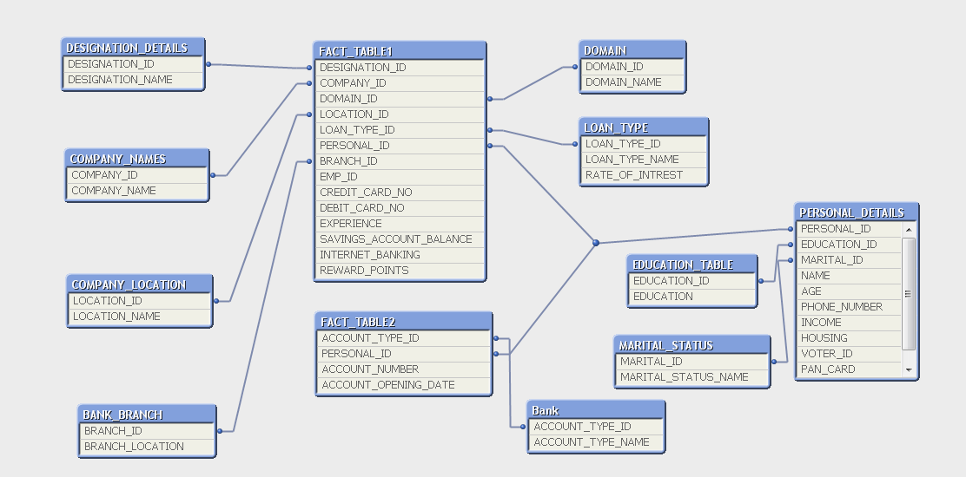

Q7

if ([AGE] > 60, 'Yes', 'No') AS [Retirement Policy];

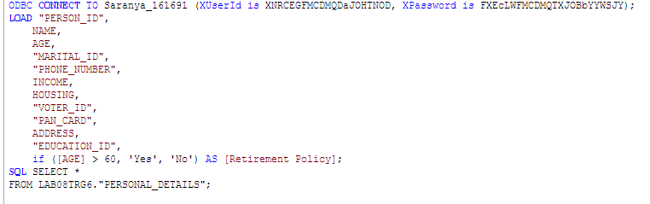

Dim: name, age

Expression: retirement policy

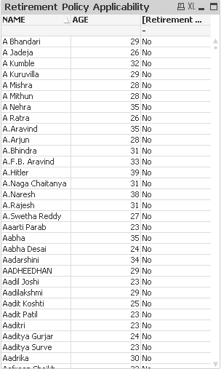

Q1

Dim: empid,

Exp: savings_account_balance

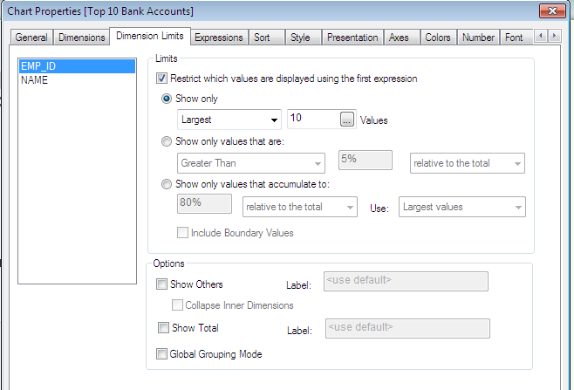

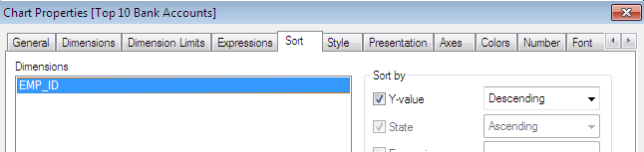

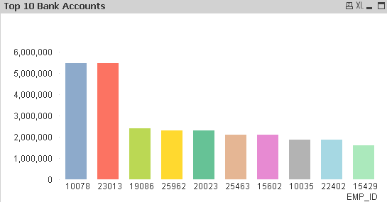

Q2

Dim: name

Loan_type_name

Marital_status_name

Housing

Exp:

Count(empid)

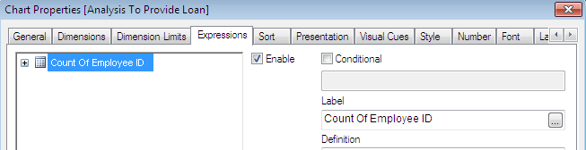

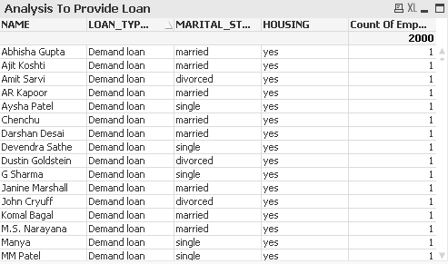

Q3)

Dim:age

Education

Exp:count(empid)

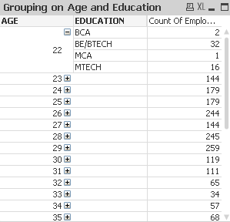

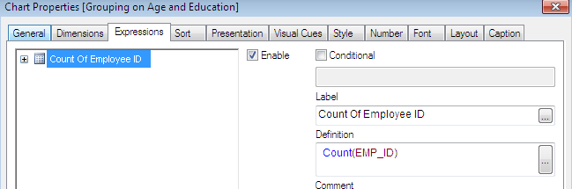

Q4)

Dim: company name

Ex:count( empid)

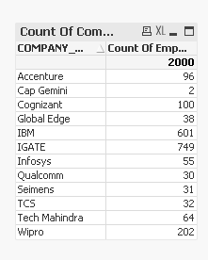

Q5)

Dim: name

Account_opening_date

Exp:count(empID)

